

**CSE 499**

**Project Report**

**iTracer**

Submitted By:

Name: Meanhazul Abedin Turase

ID: 161014027

Submission Date:

25th September 2020

i

Table of Contents

**CHAPTER 1** 1

**INTRODUCTION** 1

1.1 Aims 1

1.2 Objectives 2

1.3 Motivation and Contribution 2

**CHAPTER 2** 3

**MANAGEMENT REVIEW** 3

**CHAPTER 3** 6

**PROJECT SPECIFICATION** 6

**CHAPTER 4** 8

**METHODOLOGY APPLIED** 8

4.1 Block Diagram 8

4.2 Flow Diagram 9

4.3 Use Case Diagram 10

4.4 Data Flow Diagram (DFD) 11

**CHAPTER 5** 13

**RESULTS** 13

**CHAPTER 6** 16

**ANALYSIS** 16

6.1 Result Analysis 16

6.2 Cost Analysis 16

**CHAPTER 7** 18

**FUTURE WORK** 18

**CHAPTER 8** 19

**SOCIAL, LEGAL, ETHICAL AND ENVIRONMENTAL ISSUES** 19

**REFERENCES** 20

**DECLARATION OF MY CONTRIBUTION** 21

**APPENDICES** 22

Appendix A 22

**LIST OF TABLES**

|  |  |  |
| --- | --- | --- |
| **NO.** | **TITLE** | **PAGE** |
| **1** | iTracer Cost Analysis | **14** |

iv

LIST OF FIGURES

|  |  |  |
| --- | --- | --- |
| **NO.** | **TITLE** | **PAGE** |
| 1 | Management Diagram | 4 |
| 2 | Management Cycle | 5 |
| 3 | Use-Case Diagram of iTracer | 8 |
| 4 | Data Flow Diagram of iTracer | 9 |
| 5 | Login page of iTracer | 12 |
| 6 | Dashboard page of iTracer | 12 |
| 7 | Dashboard page of iTracer | 13 |
| 8 | Issue/Bug or Feature page of iTracer | 13 |

v

**TITLE OF THE PROJECT**

iTracer

vi

**ABSTRACT**

This Project report shows the contribution that I gave for three months on my project. I got this opportunity to build a web-based application, which they are planning to publish for the organization. However, the target audience will be the small and big organization and businesses. The project is named “iTracer” which is a web-based application. It is built for making the work easier for the organization of Bangladesh who find it hard to manage multiple projects simultaneously. Through this application, users can create account, login and logout. They can easily provide information regarding the projects. Moreover, this software will make it easier to maintain all the projects of organization with transparency. This will save time and money of an organization. It will be free of cost and very easy to use. It will require a little technical knowledge. I tried to maintain the professionalism within this project and tried to make it easier for the users to use. I follow the concept that even the users might be uneducated, so I have tried to make the application as simple as I could so that he/she can maintain the application. The user data will be protected. Thus, the users will be able to overview their projects in a short span of time using our application.

vii

# **CHAPTER 1**

## **INTRODUCTION**

In this modern era, web-based applications have developed into a significant industry. These applications are made available for use through web-server. This movement has also been felt in Bangladesh, over the past five years, where millions of people have begun to use web pages for the first time. These web-based applications and internet usage are heavily correlated. These apps are mostly used to replace human efforts. People from all over the world have stated that managing a project is a basic barrier which is significant in organization. Starting from an International organization to a small business, management applications have a huge impact to solve this barrier. The main purpose of management application is to simplify the content of one work to another without significant issue. The importance of the management application is largely structural to lead a path towards greater growth. Different management application can serve different purposes. The iTracer is a system that is addressed to resolve the real time management. It aims to comfort users in managing; projects and improves the commutation. Let’s imagine a scenario where project manager is assigns a project to a developer working in his/her company, all the people in the hierarchy of that organization may not possible situation of the project. Our system aims to help those people to know the situation of the project appearing in a web-page. The motivation for doing this project was primarily to accomplish the essentials given by understanding the globally recognize system JIRA. The opportunity to implement methodologies covered in lectures seems appealing. Besides this, In Bangladesh we really feel the need of applications that will encourage people to be in the way of succussion. New inventions and innovations in this field will visibly increase their interest in knowing the proper way of managing a project. The most important part of this system is that it is capable of transmitting data in both directions (send and receive), at the same time and the transmitted data are text mapped and transmitting Real timely. It shows mapped information.

### 1.1 Aims

The system is addressed to resolve the real time information. It aims to comfort users in manage and understanding data and improves the status of the project. Let’s imagine a scenario where project manager is assigns a project to a developer working in his/her company, all the people in the hierarchy of that organization may not possible situation of the project. Our system aims to help those people to know the situation of the project appearing in a web-page. We aim to complete the implementation of conditional P2P (Peer to Peer) data transmission system.

### 1.2 Objectives

Our technical objectives in case of developing this system are listed below-

* Managing multiple projects supported server where project manager will be able to input multiple project data of specific developer.
* Managing the project actions as follows:

i. Start Project.

ii. Changing Status.

iii. Identify clients with roles.

iv. Monitor data sending process according to client’s role.

v. Manage project state: To Do, In Progress, Done and Approved

### 1.3 Motivation and Contribution

The motivation for doing this project was primarily to accomplish the essentials given by understanding the globally recognize system JIRA. The opportunity to implement methodologies covered in lectures seems appealing. Besides this, In Bangladesh we really feel the need of applications that will encourage people to be in the way of succussion. New inventions and innovations in this field will visibly increase their interest in knowing the proper way of managing a project.

# **CHAPTER 2**

## **MANAGEMENT REVIEW**

Management is a vital aspect of the economic life of man, which is an organized group activity. It is considered as the indispensable institution in the modern social organization marked by scientific thought and technological innovations. One or the other form of management is essential wherever human efforts are to be undertaken collectively to satisfy wants through some productive activity, occupation or profession. It is management that regulates man’s productive activities through coordinated use of material resources. Without the leadership provided by management, “the resources of production remain resources and never become production”.

In the words of Drucker manager is “the life-giving dynamic element in every business. Productive resources-men, money, materials-are entrusted to the organizing skill, administrative ability and enterprising initiative of the management.”

Modern business is the complex scene of forces of change constantly at work. The size, strategy, structure, motivation of modern enterprises underlines the need of creative touch in successfully piloting their affairs. New products, new methods and techniques appear day-after-day to cater to the ever-changing trends of consumers’ tastes and needs. The ceaseless competitive drive to capture markets necessitates intellectual handling of refined requirements of consumers.

Management today is not just an exercise of blind authority or bossism but it implies scientific thinking, accurate planning and meticulous control to ensure quick and better results. Management has become a profession in view of the modern business becoming more sophisticated.

As ownership gets divorced from management, specialization in business operations becomes more marked. Proprietors, shareholders and even their directors remain comparatively in the background and experts specializing in delicate and intricate matters of industrial techniques play increasingly positive and prominent role in running the business. Professional experts like engineer, scientist, market surveyor, trained executive, researcher, technician, occupy important place in running the affairs of an enterprise today.

Management now a days, therefore, consists of cadre of experts who performs a profitable job to build-up the competitive strength of the firm and they strive to “develop and expand the assets and profits” of the proprietors. According to Drucker, “Management, which is the organ of society specially charged with making resources productive, that is, with the responsibility for organized economic advance, therefore, reflects the basic spirit of the modern age.”

In the words of George R. Terry, **“Management is a distinct process consisting of planning, organizing actuating and controlling performed to determine and accomplish objectives by the use of human beings and other resources.”**The elements of management are: planning, organizing, actuating (directing) and controlling.

These are also called the functions of management. It is through the performance of these functions that management is able to effectively utilize manpower and physical resources such as capital, machines, material, etc. to produce goods and services required by the society.

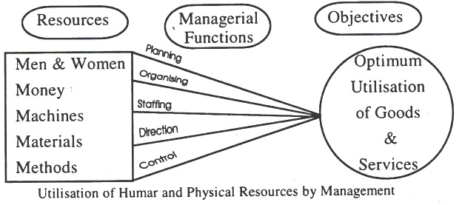

**Figure 1: Management Diagram**

Henri Fayol has defined management as a process consisting of five functions: “To manage is to forecast and plan, to organize, to command, to coordinate and to control.”

However, modern authors do not view coordination as a separate function of management. They consider it as the essence of managing. Koontz and O’Donnell have classified the functions of management as follows: planning, organizing, staffing, directing and controlling. These functions are inter-dependent and interrelated. There is no fixed sequence of their performance. They are performed more or less simultaneously.

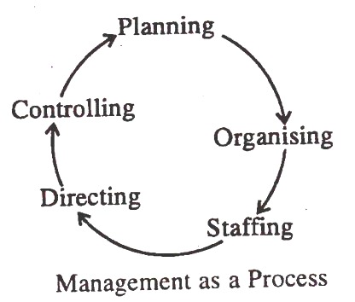**Figure 2: management Cycle**

It starts with planning and ends with controlling. But it does not mean that managerial functions are followed in a specific sequence. A manager performs all the managerial functions simultaneously. Moreover, Management is a never-ending process.

# **CHAPTER 3**

## **PROJECT SPECIFICATION**

As in the management review chapter we have identified the uniqueness of our system, also we have identified some additional features that can be added to our system in future. The main part which is multiple project management makes our system unique, so we have to ensure this part works properly. And the project specification needed to develop this application is concentrated in establishing on creating issues/bugs and features. We need to develop a system that will work effectively in real-time.

Listed are the specifications of the iTracer project-

* Project Manager and CEO will monitor the project running state.
* Project Manager, CEO and developer will insert an issue/bug and features in system.
* Through which the hierarchy can see the status of the project.
* In the web page when user successfully log in s/he will see a list of projects that were assigned by project manager. And the Project manager will be overviewing the project.
* First project manager selects a project then assign it to a developer or to team of developer. They will be notified through the web application. After being notified the developer will start working on the project.
* The developer will able to change the status of the project and also report any issues or bugs faced.
* The project manager and the CEO will be able to add features and also change the status of the project. And get updated knowledge about the project.
* After the project is done the developer will change the status of the project as done where, the tester will check the project and find any problems. If no problems are found the project will be approved, or else the project will be rejected where the project manager will be notified about the situation.

Set of requirements that are needed to achieve the specifications-

* Server Side:
  + Server: Apache Tomcat for deployment
  + Programming Language: bootstrap, html, CSS, jQuery, JavaScript
  + Framework: Bootstrap
  + Database: MySQL
* Client Side:
  + IDE: Web-based Application
  + Programming language: bootstrap, html, CSS, jQuery, JavaScript

Mentioned tools and scopes are needed for our project [14]. Data transaction was a bit difficult part of our project, since status of the project and details to be send has so many information. However, we have implemented many projects in our database.

# **CHAPTER 4**

## **METHODOLOGY APPLIED**

In the previous chapter we mentioned our project specification. Though our system supports different type of project management, we are concentrating more on software development firms. All the important information for managing the project has been collected to change the status of each project. Generally, our goal is to manage the multiple projects for the organization. Here, the project manager will add a new project and assign it to a developer. We have presented the development methodology using various diagrams throughout this chapter.

### 4.1 Use Case Diagram

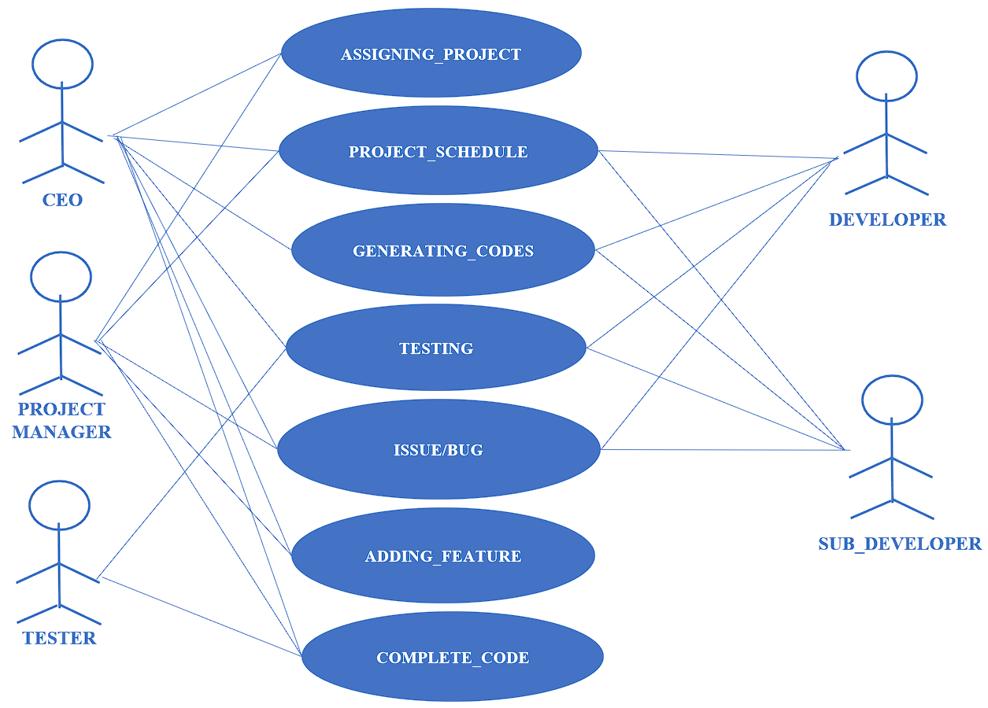

**Figure 3: Use-Case Diagram of iTracer**

In the above use-case diagram we can see there are 5 types of actors acting on 7 activities. The CEO and Project Manager will be dealing with every activity. The Project Manager will add project and feature. Developer and Sub developer is work on generating codes and report issue or bug. The tester will be testing the project to see if the work done is standard and send report to project manager. CEO has the authority do every one of the activities.

### 4.2 Data Flow Diagram (DFD)

**Figure 4: Data Flow Diagram of iTracer**

Functional requirement refers to those requirements which specify what the system should do. A functional requirement will describe a behavior of function of the system when certain conditions are met. There are 7 different functional requirements of our project.

1. Assigning Project:

The system will have a procedure to add project. Add all the specific entities will interact with this process. This process will provide connection details based on each entity’s connection status.

2. Project Scheduling:

This Process will provide the project status of each entity depending on their Request Type.

3. Generating Codes:

This process will provide the actual work done by different entity.

4. Testing:

Only the tester entity of this system gets the privilege of choosing if the work done is standard or not. Other than tester both project manager and CEO have the authority in this process.

5. Issue/Bug:

Only the developer and sub-developer entity will interact with this process. The developer and sub-developer will submit the issues or bugs found in project through this process.

6. Feature:

Only the project manager will interact with this process. The project manager will add the features through this process.

7. Complete Code:

Project manager and Tester of our system will interact with this process. Project manager and Tester will provide the finish product from the project.

# **CHAPTER 5**

## **RESULTS**

The methodology showed the development process of our system. We can see the overall development process has been done on side as the software is web-based. The data is inserted and represented on the table. And the implementation of this lies on Dashboard and Web-based application.

The development of iTracer consists of two major parts.

• Dashboard and

• Web-Based application.

The Dashboard is developed on html, CSS and java script. The dashboard has been designed using html and CSS. A bootstrap template has been implemented before the designing. The web pages are designed by bootstrap. The main three pages of web-Based Application are –

o Login

o Dashboard

o Issue/bug And Feature

The first page is login (Figure.5). Two input fields respectively take input of email and password. Here user gives the login information to login to their specified dashboard. Web application is connected to database.

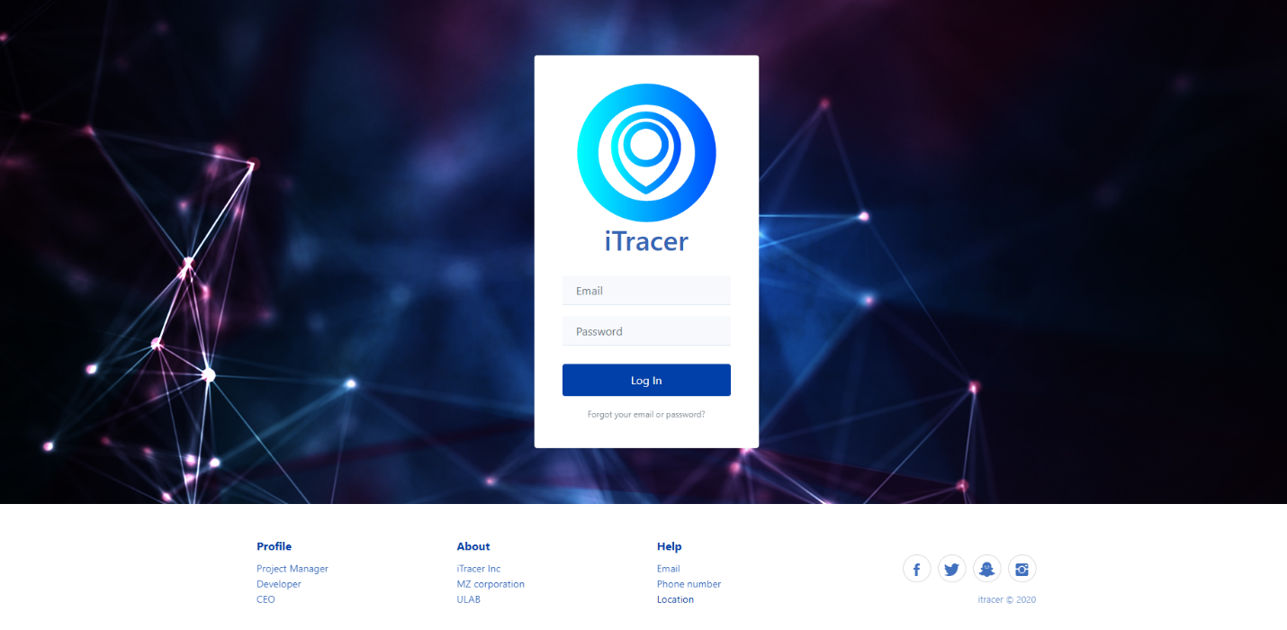

**Figure 5: Login Page of iTracer**

The second page is the Dashboard page (Figure.6 and Figure.7). To manage projects and developers I had to build the dashboard in such a way so that multiple projects can be handled at the same time.

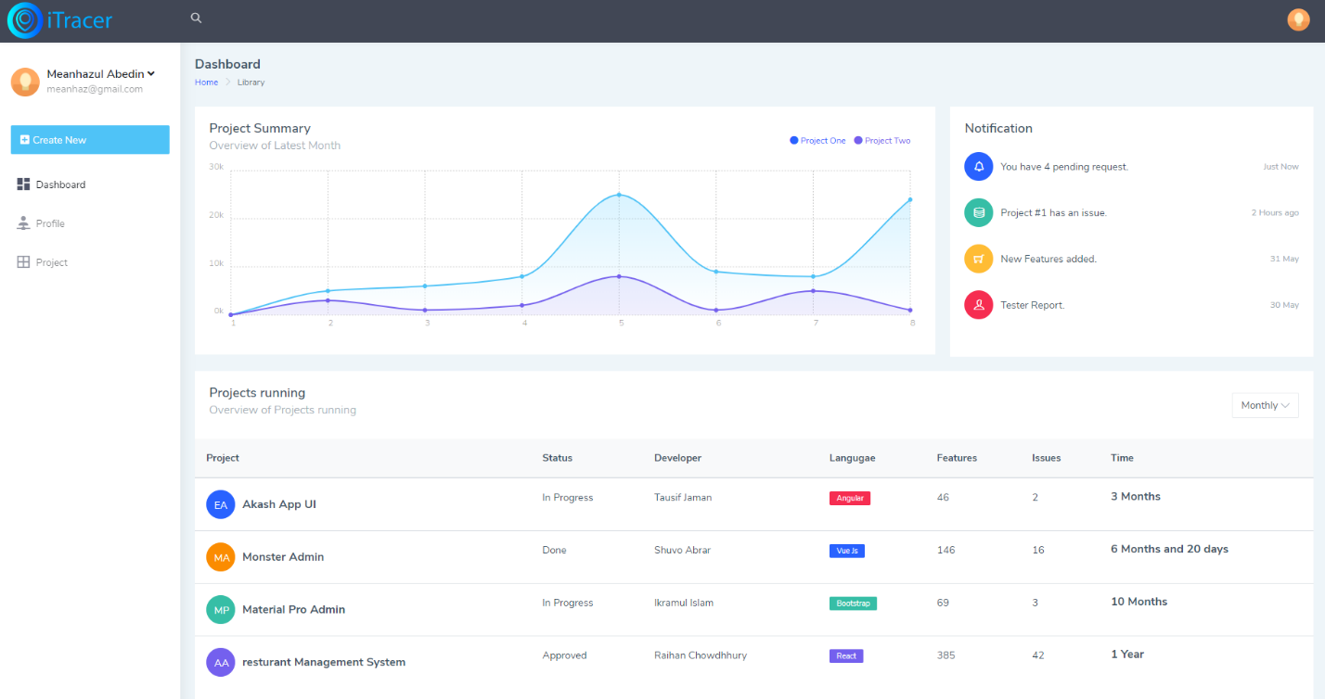

**Figure 8: Dashboard of iTracer**

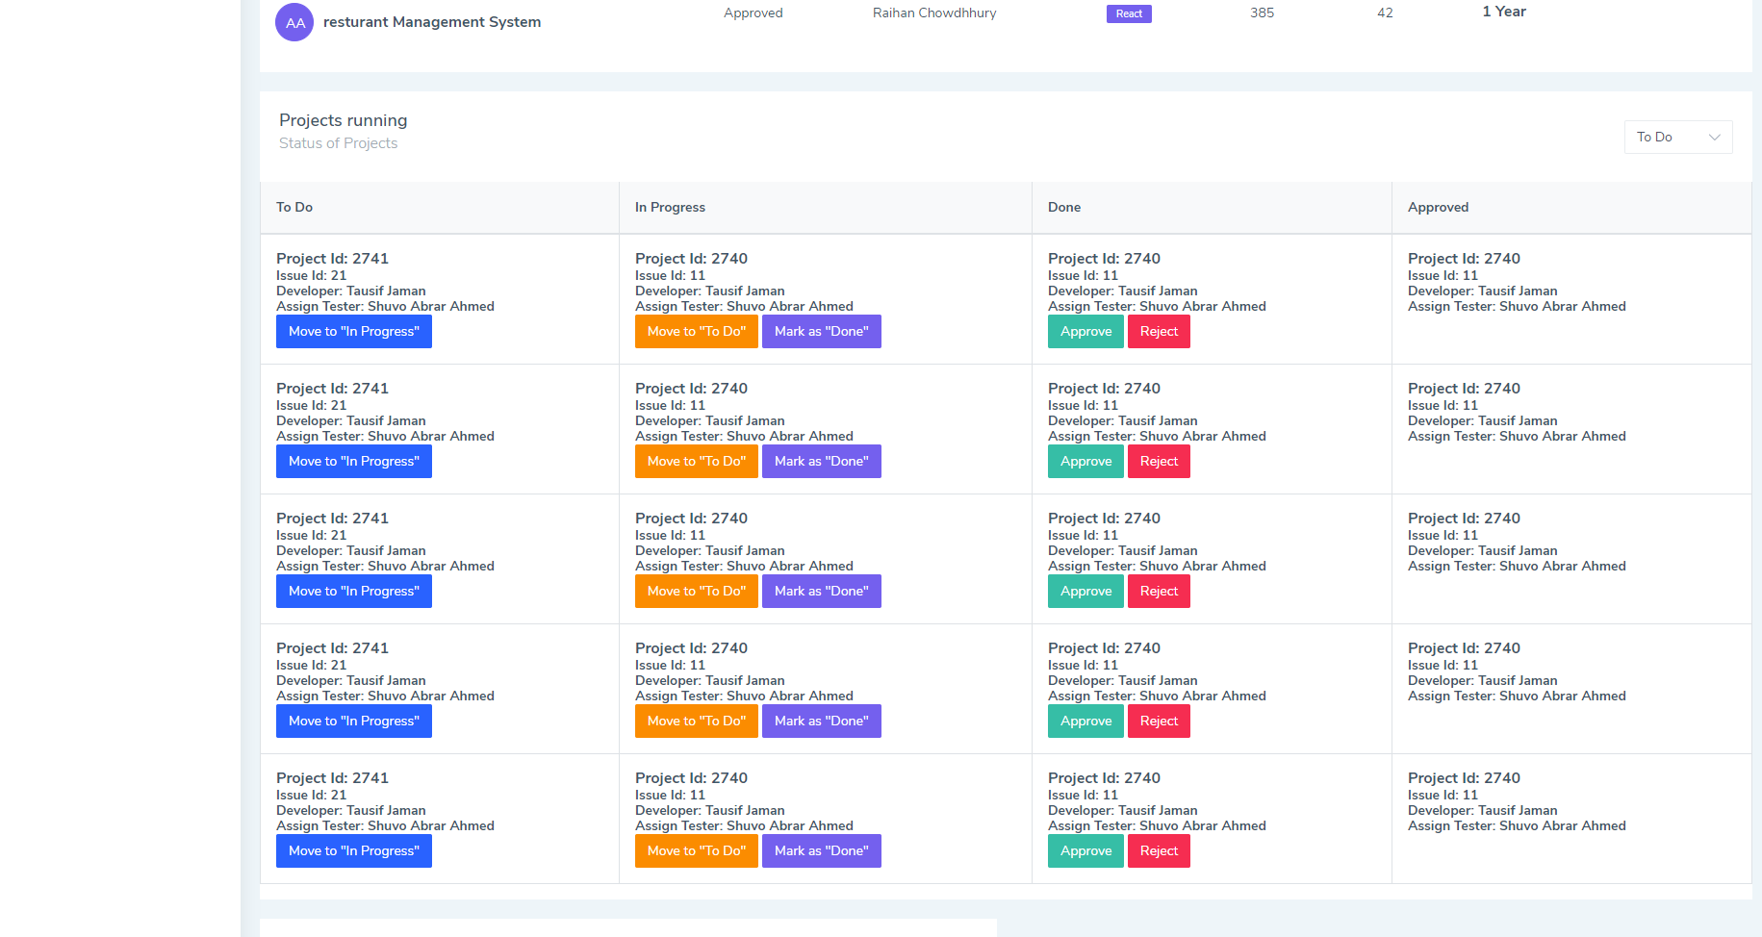

**Figure 7: Dashboard of iTracer**

The Issue/bug and Feature page (Figure.10) Is where new issues/bugs are reported by developer or sub-developer and also add new feature by project manager.

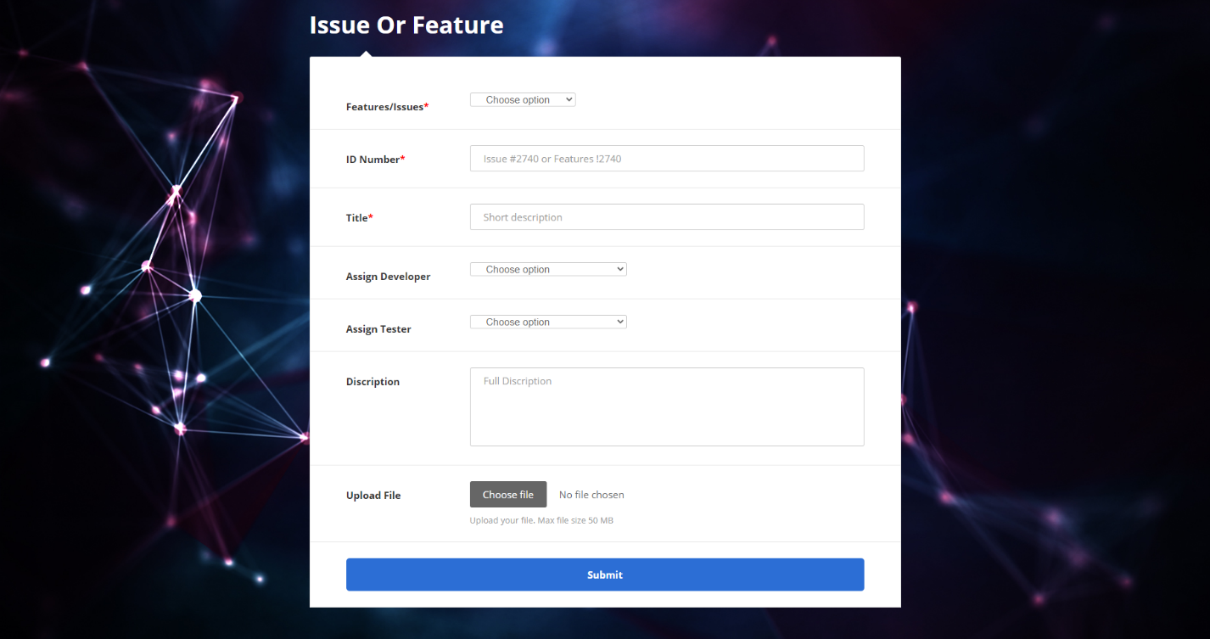

**Figure 8: Issue/Bug or Feature Page of iTracer**

# **CHAPTER 6**

## **ANALYSIS**

The implementation of the project specifications applying the methodologies have been shown in the previous chapter. The project specification has been met successfully, but this is not the end of the project, analysis of the result and analysis of the cost also plays a great role in the efficient process of developing a project. To evaluate our result, result analysis and cost analysis has been discussed below.

### 6.1 Result Analysis

After analyzing the result of the project, we can come to a few points. There were challenges to establish a status update effectively. Real time data transmission is well established. The role management of project manager and developer is well stable. Each project showed in selected status by developer and show to the project manager and higher ups. Dynamically increment of status, is shown effectively. According to the listed features the product came out good.

### 6.2 Cost Analysis

Table 1: The iTracer Cost Analysis

|  |  |  |
| --- | --- | --- |
| **Cost Type** | **Description** | **Cost** |
| Hardware Cost | Nothing | Tk. 00/=  Tk. 00/= |
| Software Cost | Domain- 1 Year (Tk.1500/=)  VPS Hosting- 1 Year  (Tk. 1600/= per month)  (12*1600) = Tk. 19,200/= | Tk.1500/=  Tk. 19,200/= |
| Developer Cost | Senior Developer (1):  Per week- 40 hours,  Per Month- Tk. 30,000/=  Development Period: 2 months  Total: Tk. 60,000/=  Junior Developer (2):  Per week- 40 hours,  Per Month- Tk. 20,000/=  Development Period: 2 months  Each Person: Tk. 40,000/=  Total: Tk. 80,000/= | Tk. 60,000/= (Sr. Developer)  Tk. 80,000/= (Jr. Developer) |
| Maintenance Cost | Monthly maintenance  (Tk. 5,000/=) | Tk. 5,000/= |
| Miscellaneous Cost |  | Tk. 10,000/= |
|  | Total | Tk. 1,75,700/= |

The development period of iTracer is 3 months. The cost of this project consists of few different categories such as hardware cost, software cost, development cost, maintenance cost and miscellaneous cost. According to **Table 1** the hardware cost is nothing as it is a web-based application Tk. 00/=. Software cost consists of domain- 1 Year (Tk.1500/=), VPS Hosting- 1 Year (Tk. 1600/= per month) for 1 year it will be (12*1600) = Tk. 19,200/=. 3 developers are engaged in this project. Senior Developer (1): Per week- 40 hours, Per Month- Tk. 30,000/=, Junior Developer (2): Per week- 40 hours, Per Month- Tk. 20,000/=. Maintenance cost per month Tk. 5,000/=. Miscellaneous Cost approximately Tk. 10,000/=. In total the cost for this project is Tk. 1, 75,700/=.

# **CHAPTER 7**

## **FUTURE WORK**

iTracer is an industrial system. This project will be beneficiary for the web-based market. According to our findings, designs and research it is estimated to be a successful project if worked on properly. The goal of our work was to develop an application that will work practically in real life to remove management barriers. In future, we will also add features like- Chart Builder, Alarm and Timer for projects and email notification etc.

This paper resembles the design and development of the iTracer app. There is a huge possibility of extending the features of this project in future. For example, adding features like multiple notification system and projecting timeline details of project. Email notification and google account integration will be added in future. Representing and Updating of status at a time will be a mind soothing feature. Multiple projects will be added so that this system can be used in many projects.

# **CHAPTER 8**

## **SOCIAL, LEGAL, ETHICAL AND ENVIRONMENTAL ISSUES**

According to our planning of the development of this application, we can ensure that the solution to the design problem is safe to the public and the environment. Primarily, this system will not need any special permission of the user. It is planning to utilize only the permission to know the state of internet connectivity. So, it doesn’t need the access of someone’s personal data.

It can also have a great economic impact, because in today’s digital world where everything is getting digitalized people prefer more involvement of technology in every phase of their lives. This project throws a light in this concept, the iTracer will grow more interest to learn project management, cause faster growth in organization.

# **REFERENCES**

[1] https://www.atlassian.com/software/jira

[2] https://www.bugzilla.org/

[3] https://www.zoho.com/

[4] https://www.happyfox.com/

[5] https://www.w3schools.com/

[6] https://getbootstrap.com/

[7] https://stackoverflow.com/

# **DECLARATION OF MY CONTRIBUTION**

I am aware of and understand the university’s policy on plagiarism and We certify that the iTracer is my own work, except where indicated by referencing, I declare that this work has not been submitted for any other degree or professional qualification except as specified. The data presented in this paper was obtained in experiments carried out by us after developing the system. The preparation and execution of the idea, and the data analysis and interpretation are entirely by our own work.

Signature of

Meanhazul Abedin Turase:

________________________

# **APPENDICES**

## Appendix A

Logo of the iTracer.

